Formscriber AI

**Software Requirements Specification**

For Report Generator Tool

Version 1.2

Presented by

Stefon Williams

Caleb Crickette

Thomas Barton

Eugene Kim

Nicholas Ballo

Abdul Kamara

Sohail Sobhani

Revision History

|  |  |  |  |
| --- | --- | --- | --- |
| **Date** | **Version** | **Description** | **Author** |
| 01/17/2021 | 1.0 | First Revision | Thomas Barton |
| 01/25/2021 | 1.1 | Formatting and editing use cases | Eugene Kim |
| 01/27/2021 | 1.2 | Adding in use cases related to extracting form data | Eugene Kim |
| 01/29/2021 | 1.3 | Editing and corrections | Nick Ballo |
| 01/31/2021 | 1.14 | Additional Assumptions and Use Case | Nick Ballo |
| 2/21/2021 | 2.0 | Updating requirements, project name (due to GCP policies), and other minor details | Eugene Kim |

Table of Contents

1. Introduction 4

1.1 Purpose 4

1.2 Scope 4

1.3 Definitions, Acronyms and Abbreviations 4

1.4 References 4

1.5 Overview 4

2. Overall Description 5

2.1 Use-Case Model Survey 6

2.2 Assumptions and Dependencies 6

3. Specific Requirements 7

3.1 Use-Case Reports 7

3.1.1 Use Case: Isolate primary user’s voice for use within the service. 7

3.1.2 Use Case: Receive report identifier (id or name) from user. 8

3.1.3 Use Case: Get report fields from database. 9

3.1.4 Use Case: Process report contents and fields. 10

3.1.5 Use Case: Generate dynamic intents to capture report fields. 12

3.1.6 Use Case: Identify report contents extracted by the Dialogflow service. 13

3.1.7 Use Case: Insert extracted entities and data into a database. 15

3.1.8 Use Case: Service is integrated with mobile application 16

3.1.9 Use Case: Initiate connection with database 17

Error! Hyperlink reference not valid.**Error! Hyperlink reference not valid.Error! Hyperlink reference not valid.Error! Hyperlink reference not valid.Error! Hyperlink reference not valid.Error! Hyperlink reference not valid.**Error! Hyperlink reference not valid.**Error! Hyperlink reference not valid.Error! Hyperlink reference not valid.**Error! Hyperlink reference not valid.**Error! Hyperlink reference not valid.Error! Hyperlink reference not valid.Error! Hyperlink reference not valid.Error! Hyperlink reference not valid.Error! Hyperlink reference not valid.Error! Hyperlink reference not valid.Error! Hyperlink reference not valid.Error! Hyperlink reference not valid.Error! Hyperlink reference not valid.Error! Hyperlink reference not valid.Error! Hyperlink reference not valid.Error! Hyperlink reference not valid.Error! Hyperlink reference not valid.Error! Hyperlink reference not valid.Error! Hyperlink reference not valid.Error! Hyperlink reference not valid.Error! Hyperlink reference not valid.Error! Hyperlink reference not valid.**

Software Requirements Specification

# Introduction

UMGC SWEN670 is looking to create a report generation tool that listens to the user’s voice using a mobile device and feeds it into GCP’s Dialogflow service, which interprets the voice to text. The service processes and stores the extracted data into a final report, which can be edited and updated on a web interface. The users of this tool are primarily public service professionals trying to gather information from others in an interrogation type format. The tool is designed to help collect and process this information for the users.

This SRS document will only document the requirements for the Dialogflow portion of the report generation tool.

## Purpose

The purpose of this document is to illustrate a model of the requirements for the DialogFlow portion of the report generation tool and will be the basis for the design for the various intents and aspects for our product.

There are several use cases for implementation as follows:

1. Isolate primary user’s voice for use within the service.
2. Receive report identifier (id or name) from user.
3. Get report fields from database.
4. Process report contents and fields.
5. Generate dynamic intents to capture report fields.
6. Identify entities extracted by the Dialogflow service.
7. Insert extracted entities and data into a database for report generation.
8. Dialogflow service is integrated with the mobile application.

## Scope

This SRS applies only to the DialogFlow service portion of the report generation tool, which is responsible for the interpretation of phrases from the mobile portion of the tooland inserting the extracted data into a database for the web API that will put the data within a report for creation or updating.

The DialogFlow team will also be responsible for developing the webhook service that will pass information to the form templates present on the web servers.

## Definitions, Acronyms and Abbreviations

|  |  |
| --- | --- |
| Term | Definition |
| SRS | Software Requirements Specification |
| DialogFlow | Google AI service to interpret speech to text |
| GCP | Google Cloud Platform |

## References

Initiating document:

Assadullah, M. (2021). SWEN670 Kickoff Meeting. Retrieved from: <https://learn.umgc.edu/d2l/le/news/545048/2101272/view>

## Overview

There are two overall sections of the SRS, the Overall Description which is in high level detail, and specific requirements which are going to be in more fine-grained detail.

# Overall Description

The interpreter will be taking in data from the mobile application. The data ingested will be in the form of text, which can be directly put into the DialogFlow application, which is triggered with an invocation controlled by a Google Action. The invocation will be used by the provider or professional who needs help filling out a report which triggers Dialogflow logic. The input will likely have a few key words to queue for the augmentation of the interpretation. The internal workings of the interpreter will consist of many training phrases which will have intents that will extract specific data. Outbound data will consist of the interpreted data to the web form service.

For an overview, please see below UML sequence diagram illustrating the scope and responsibilities of DialogFlow and DialogFlow webhook:

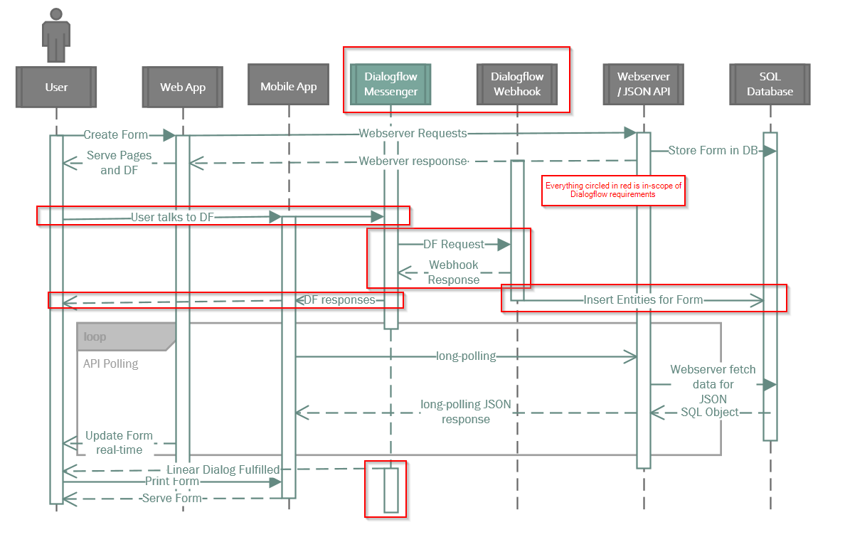

Figure 1 – Overall high level process flow for the entire application

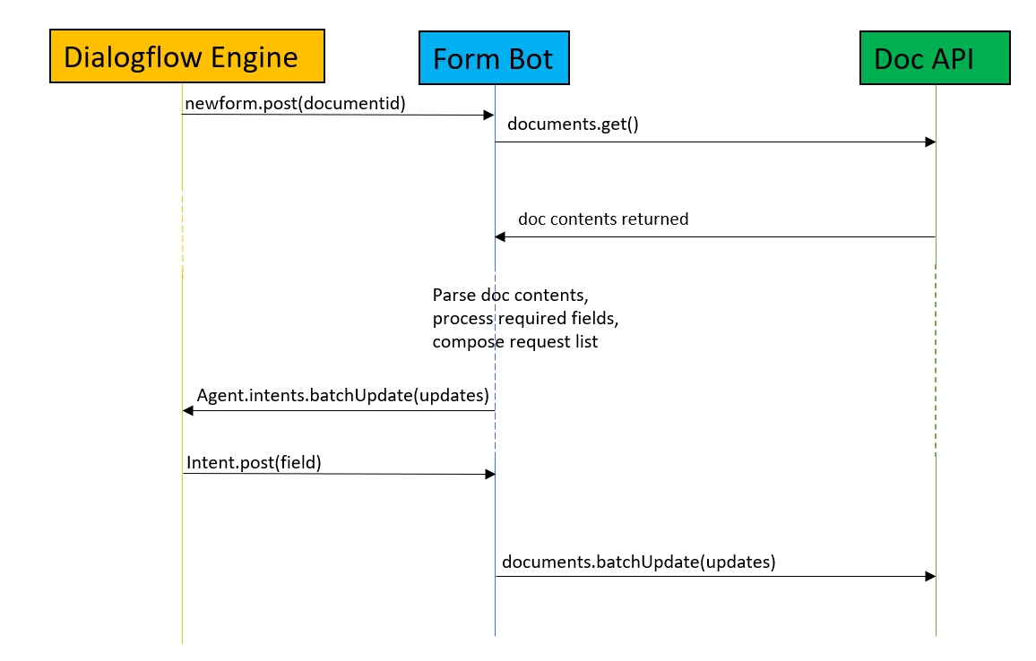

Figure 2 - Dialogflow process flow

## Use-Case Model Survey

These areuse cases that make up the requirements for the system. More details in section 3.

| Use Cases | Description |
| --- | --- |
| 1. Isolate primary user’s voice for use within the service. | Discern primary user’s voice as the input to the Dialogflow service. |
| 1. Receive report identifier (id or name) from user. | Identify report identifier from user to receive report metadata. This could be an id or unique name. |
| 1. Get report fields from database. | Retrieve report fields from database using report identifier. |
| 1. Process report contents and fields. | Process report fields and content into internal data structure. |
| 1. Generate dynamic intents to capture report fields. | Use retrieved form fields to generate dynamic intents in Dialogflow. |
| 1. Identify report contents extracted by the Dialogflow service. | Identify report contents that are recognized from the user’s voice and dynamic intents using Dialogflow. |
| 1. Store extracted report contents into a database. | Extracted report contents from user’s voice must be inserted into database to generate the final report. |
| 1. Dialogflow service is integrated with the mobile application. | DialogFlow engine can be used and accessed by the mobile application. |
| 1. Initiate connection with database | Database connection is initialized and any exceptions are handled and presented to the user. |

## Assumptions and Dependencies

A stable internet connection is required at all times in order for the application to connect to the Dialogflow service. The user will need to use a modern smart phone that is capable of running a voice assistant application.

Current project assumptions project that only DialogFlow ES will be necessary.

The Formscriber AI is dependent on the mobile application for implementing our API service into the application, and the web service will create/update the interpreted data within a report template.

# Specific Requirements

## Use-Case Reports



























































### Use Case: Isolate primary user’s voice for use within the service.

**Summary:** Discern primary user’s voice as the input to the Dialogflow service.

**Preconditions:**

* User opens the mobile application’s assistant page.

**Triggers:**

* User selects button to record audio

**Basic course of events (Scenario):**

* 1. User selects button to record audio for information gathering
  2. UI displays guided messages to give user some audio prompts.
  3. User initiates voice activated service by either saying one of the audio prompts or identifying a report to be created.

**Internal Precondition:**

|  |  |  |
| --- | --- | --- |
| **Input** | **System** | **Output** |
| User starts mobile application | Mobile application loads | Mobile UI view displayed |
| User selects assistant page | Dialogflow assistant loads | Dialogflow UI displayed with guided audio prompts. |
| User says audio prompt. | Dialogflow intent mapping to response. | Response displayed on UI based on audio prompt given. |

**Alternate path:** User identifies report

|  |  |  |
| --- | --- | --- |
| **Input** | **System** | **Output** |
| User starts mobile application | Mobile application loads | Mobile UI view displayed |
| User selects assistant page | Dialogflow assistant loads | Dialogflow UI displayed with guided audio prompts. |
| User identifies report identifier for report creation. | Dialogflow intent mapping to response. Stores report identifier | Response returned confirming request. See REQ 3.1.3 and 3.1.4 for further information |

**Alternate path:** User says an unrecognized intent or audio

|  |  |  |
| --- | --- | --- |
| **Input** | **System** | **Output** |
| User starts mobile application | Mobile application loads | Mobile UI view displayed |
| User selects assistant page | Dialogflow assistant loads | Dialogflow UI displayed with guided audio prompts. |
| User says unrecognized audio prompt. | Dialogflow intent mapping to fallback response. | Response displayed on UI to try again from the following audio prompts. |

### Use Case: Receive report identifier (id or name) from user.

**Summary:** Identify report identifier from user to receive report metadata. This could be an id or unique name.

**Preconditions:**

* Mobile application is loaded and assistant page is displayed.

**Triggers:**

* User initiates report creation from the assistant page.

**Basic course of events (Scenario):**

* 1. User selects button to record audio for information gathering
  2. UI displays guided messages to give user some audio prompts.
  3. User initiates voice activated service by identifying a report to be created by id or name.

**Internal Precondition:**

|  |  |  |
| --- | --- | --- |
| **Input** | **System** | **Output** |
| User starts mobile application | Mobile application loads | Mobile UI view displayed |
| User selects assistant page | Dialogflow assistant loads | Dialogflow UI displayed with guided audio prompts. |
| User identifies report identifier for report creation. | Dialogflow intent mapping to response. Stores report identifier in memory. |  |

### Use Case: Get report fields from database.

**Summary:** Retrieve report fields from database using report identifier.

**Preconditions:**

* Database exists and is ready to accept connections.
* Report exists with valid form fields and report identifier.

**Triggers:** User initiates process by saying intent to create report with report identifier.

**Basic course of events (Scenario):**

1. User says they want to create a report for report x, where x is a report identifier
   1. Report identifier can be a name or id
2. UI acknowledges request and displays confirmation of report fields.
3. User confirms.

**Internal Precondition:**

|  |  |  |
| --- | --- | --- |
| **Input** | **System** | **Output** |
| User starts mobile application | Mobile application loads | Mobile UI view displayed |
| User selects assistant page | Dialogflow assistant loads | Dialogflow UI displayed with guided audio prompts. |
| User identifies report identifier for report creation. | Dialogflow intent mapping to response. Stores report identifier |  |
|  | Dialogflow queries database using report identifier. See Req 3.1.9 for further information. |  |
|  |  | Response returned confirming available report fields to fill. |

**Alternate Path:** Report does not exist

|  |  |  |
| --- | --- | --- |
| **Input** | **System** | **Output** |
| User starts mobile application | Mobile application loads | Mobile UI view displayed |
| User selects assistant page | Dialogflow assistant loads | Dialogflow UI displayed with guided audio prompts. |
| User identifies report identifier for report creation. | Dialogflow intent mapping to response. Stores report identifier |  |
|  | Dialogflow queries database using report identifier. See Req 3.1.9 for further information. |  |
|  |  | Response returned indicating no report available and to create report on web UI. |

### Use Case: Process report contents and fields.

**Summary:** Process report fields and content into internal data structure.

**Preconditions:**

* Database exists and is ready to accept connections.
* Report exists with valid form fields and report identifier.

**Triggers:**

* User identifies report to be created.

**Basic course of events (Scenario):**

1. User says intent to create report with report identifier (name or id)
2. System retrieves report fields and returns response confirming fields.
3. User confirms.
4. System stores report fields in memory for further processing. See REQ 3.1.5 for more information.

**Internal Precondition:**

|  |  |  |
| --- | --- | --- |
| **Input** | **System** | **Output** |
| User starts mobile application | Mobile application loads | Mobile UI view displayed |
| User selects assistant page | Dialogflow assistant loads | Dialogflow UI displayed with guided audio prompts. |
| User identifies report identifier for report creation. | Dialogflow intent mapping to response. Stores report identifier |  |
|  | Dialogflow queries database using report identifier. See Req 3.1.9 for further information. |  |
|  |  | Response returned confirming available report fields to fill. |
| User confirms. | System stores fields into internal data structure. | Response returned confirming application is ready to receive report data. |

**Alternate Path:** User does not confirm valid report fields and there are multiple reports matching report identifier.

|  |  |  |
| --- | --- | --- |
| **Input** | **System** | **Output** |
| User starts mobile application | Mobile application loads | Mobile UI view displayed |
| User selects assistant page | Dialogflow assistant loads | Dialogflow UI displayed with guided audio prompts. |
| User identifies report identifier for report creation. | Dialogflow intent mapping to response. Stores report identifier |  |
|  | Dialogflow queries database using report identifier. See Req 3.1.9 for further information. |  |
|  |  | Response returned confirming available report fields to fill. |
| User does not confirm. | System retrieves a different report. | Response returned confirming available report fields to fill on different form. Repeat until confirmation. |

**Alternate Path:** User does not confirm valid report fields and there are no multiple reports matching report identifier.

|  |  |  |
| --- | --- | --- |
| **Input** | **System** | **Output** |
| User starts mobile application | Mobile application loads | Mobile UI view displayed |
| User selects assistant page | Dialogflow assistant loads | Dialogflow UI displayed with guided audio prompts. |
| User identifies report identifier for report creation. | Dialogflow intent mapping to response. Stores report identifier |  |
|  | Dialogflow queries database using report identifier. See Req 3.1.9 for further information. |  |
|  |  | Response returned confirming available report fields to fill. |
| User does not confirm. | System retrieves no other reports. | Response returned informing user to create form on web UI. |

### Use Case: Generate dynamic intents to capture report fields.

**Summary:** Use retrieved form fields to generate dynamic intents in Dialogflow.

**Preconditions:**

* Report exists with valid form fields and report identifier.

**Triggers:**

* User voices intent to create report and confirms report fields.

**Basic course of events (Scenario):**

1. User voices intent to create report and confirms report fields.
2. System generates intents for report fields to identify the field name and any data after that.
   1. For example, the heart rate field would identify any sentence with heart rate in it and store all words after the key word as the report content.
   2. Any existing intent will not be overwritten, they will automatically be handled by Dialogflow as existing and will be skipped.

**Internal Precondition:**

|  |  |  |
| --- | --- | --- |
| **Input** | **System** | **Output** |
| User starts mobile application | Mobile application loads | Mobile UI view displayed |
| User selects assistant page | Dialogflow assistant loads | Dialogflow UI displayed with guided audio prompts. |
| User identifies report identifier for report creation. | Dialogflow intent mapping to response. Stores report identifier |  |
|  | Dialogflow queries database using report identifier. See Req 3.1.9 for further information. |  |
|  |  | Response returned confirming available report fields to fill. |
| User confirms report fields as valid. | System stores report fields into internal data structure. |  |
|  | System generates intents for report fields to identify the field name and any data after that. |  |
|  |  | Response returned that system is ready for report data. |

### Use Case: Identify report contents extracted by the Dialogflow service.

**Summary:** Identify report contents that are recognized from the user’s voice and dynamic intents using Dialogflow.

**Preconditions:**

* Report exists with valid form fields and report identifier.

**Triggers:**

* User voices intent to create report and confirms report fields.

**Basic course of events (Scenario):**

1. User voices intent to create report and confirms report fields.
2. User voices report field content based on generated intents.
   1. For example, the heart rate field would be filled in by the user saying “heart rate 60 bpm” where heart rate is the key and the content is 60 bpm.

**Internal Precondition:**

|  |  |  |
| --- | --- | --- |
| **Input** | **System** | **Output** |
| User starts mobile application | Mobile application loads | Mobile UI view displayed |
| User selects assistant page | Dialogflow assistant loads | Dialogflow UI displayed with guided audio prompts. |
| User identifies report identifier for report creation. | Dialogflow intent mapping to response. Stores report identifier |  |
|  | Dialogflow webhook queries database using report identifier. See Req 3.1.9 for further information. |  |
|  |  | Response returned confirming available report fields to fill. |
| User confirms report fields as valid. | System stores report fields into internal data structure. |  |
|  | System generates intents for report fields to identify the field name and any data after that. |  |
|  |  | Response returned that system is ready for report data. |
| User voices report field content. | Dialogflow processes report field content. | Response returned confirming identified report field and content. |
| User confirms report field and content. | System stores field in database. See REQ 3.1.7 | Response returned for successful interaction. |

**Alternate Path:** User does not confirm extracted fields.

|  |  |  |
| --- | --- | --- |
| **Input** | **System** | **Output** |
| User starts mobile application | Mobile application loads | Mobile UI view displayed |
| User selects assistant page | Dialogflow assistant loads | Dialogflow UI displayed with guided audio prompts. |
| User identifies report identifier for report creation. | Dialogflow intent mapping to response. Stores report identifier |  |
|  | Dialogflow webhook queries database using report identifier. See Req 3.1.9 for further information. |  |
|  |  | Response returned confirming available report fields to fill. |
| User confirms report fields as valid. | System stores report fields into internal data structure. |  |
|  | System generates intents for report fields to identify the field name and any data after that. |  |
|  |  | Response returned that system is ready for report data. |
| User voices report field content | Dialogflow extracts report field content. | Response returned confirming identified report field and content. |
| User does not confirm report field and content. |  | Fallback response returned prompting user to try again. |

**Alternate Path:** System does not understand user.

|  |  |  |
| --- | --- | --- |
| **Input** | **System** | **Output** |
| User starts mobile application | Mobile application loads | Mobile UI view displayed |
| User selects assistant page | Dialogflow assistant loads | Dialogflow UI displayed with guided audio prompts. |
| User identifies report identifier for report creation. | Dialogflow intent mapping to response. Stores report identifier |  |
|  | Dialogflow webhook queries database using report identifier. See Req 3.1.9 for further information. |  |
|  |  | Response returned confirming available report fields to fill. |
| User confirms report fields as valid. | System stores report fields into internal data structure. |  |
|  | System generates intents for report fields to identify the field name and any data after that. |  |
|  |  | Response returned that system is ready for report data. |
| User voices report field content | Dialogflow unable to interpret user’s voice. | Fallback response returned indicating inability to understand user and to try again. |

### Use Case: Insert extracted entities and data into a database.

**Summary:** After DialogFlow has extracted entities and relevant form data, the service needs to insert the data into a database so that other teams can take it and update the forms as needed.

**Preconditions:**

* Database exists and is ready to accept connections.
* Report exists with valid form fields and report identifier.

**Triggers:**

* Voice activated communication has extracted intent and data.

**Basic course of events (Scenario):**

1. User says the following to DialogFlow messenger “The patient is feeling y”.
2. DialogFlow shall recognize an intent named x.
3. DialogFlow will extract the entity y.
4. Intent x and entity y will be stored in a data structure in the application.

**Internal Precondition:** A valid intent and data is extracted from the user’s speech.

|  |  |  |
| --- | --- | --- |
| **Input** | **System** | **Output** |
| User talks into DialogFlow with a predefined intent trigger | DialogFlow recognizes intent and extracts relevant data from speech. | Entities are extracted |
|  | System processes entities into meaningful data structure. |  |
|  | System stores data in database | Response given to user for success or failure. |

### 

### Use Case: Service is integrated with mobile application

**Summary:** DialogFlow will provide an API to be integrated into the mobile application, thus our service needs to be able to be accessed by the mobile application.

**Preconditions:**

* Mobile application exists and is ready to integrate.

**Triggers:**

* Mobile Application start up process.

**Basic course of events (Scenario):**

1. Mobile application starts and loads DialogFlow messenger UI.
2. User interacts with application to connect to DialogFlow

**Internal Precondition:** Mobile app works as intended with regards to recording audio or text and sending data to DialogFlow.

|  |  |  |
| --- | --- | --- |
| **Input** | **System** | **Output** |
| User starts mobile application | Mobile application loads | Mobile UI view displayed |
| User selects assistant page | Dialogflow assistant loads | Dialogflow UI displayed with guided audio prompts. |
| User says audio prompt. | Dialogflow intent mapping to response. | Response displayed on UI based on audio prompt given. |

### Use Case: Initiate connection with database

**Summary:** A connection needs to be initiated with the database so that data can be placed into it.

**Preconditions:**

* Database exists and is ready to accept connections.

**Triggers:**

* Mobile Application start up process.

**Basic course of events (Scenario):**

1. A connection is established with the database.

|  |  |  |
| --- | --- | --- |
| **Input** | **System** | **Output** |
| Dialogflow service requests connection with database. | Database is contacted. | Connection is established. |

**Alternate path:** The connection failed.

|  |  |  |
| --- | --- | --- |
| **Input** | **System** | **Output** |
| Dialogflow service requests connection with database. | Database is unable to be contacted. | Error report stating that the database was unreachable. |